Amazon | OA 2020 | Ways to Split String Into Prime Numbers

LEETCODE : <https://leetcode.com/discuss/interview-question/833164/>

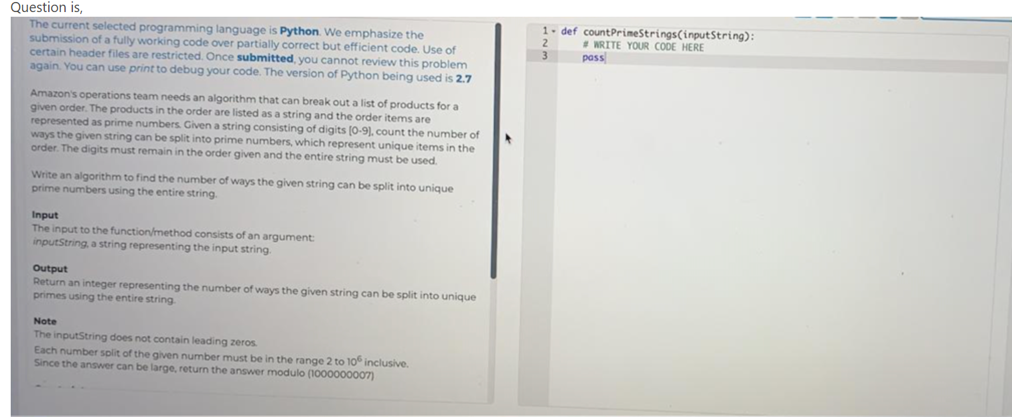

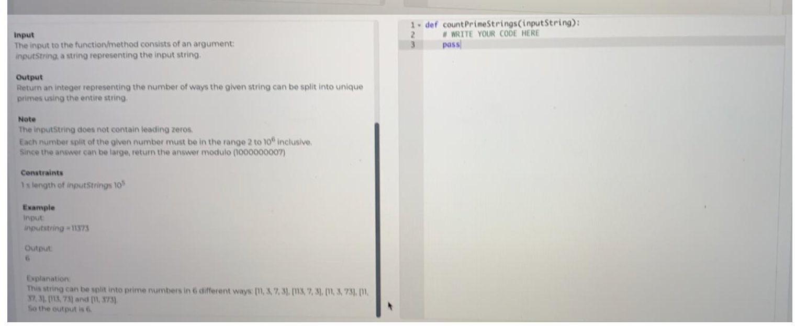

public static void main(String[] args) {

int n = 11373;

System.out.println(solve(n));

}

private static int solve(int n) {

int mod = (int)1e9 + 7;

boolean[] arr = new boolean[(int)1e6 + 1];

Arrays.fill(arr, true);

for(int i=2;i\*i<=(int)1e6;i++) {

if(arr[i]) {

for(int j=i;j\*i<=(int)1e6;j++) {

arr[i\*j] = false;

}

}

}

arr[1] = false;

arr[0] = false;

String s = String.valueOf(n);

int[] dp = new int[s.length() + 1];

dp[0] = 1;

for(int i=1;i<=s.length();i++) {

for(int j=Math.max(0, i-6);j<i;j++) {

if(arr[Integer.parseInt(s.substring(j, i))]) {

dp[i] = (dp[i] + dp[j]) % mod;

}

}

}

return dp[s.length()];

}

private static List<List<Integer>> output = new ArrayList<List<Integer>>();

public static void main(String args[]) throws Exception{

splitIntoPrimeNumbers("11373", new ArrayList<Integer>());

System.out.println(output);

}

private static void splitIntoPrimeNumbers(String input, List<Integer> list) throws Exception{

if(input.length()==0) {

output.add(list);

}

for(int i=1; i<=input.length(); i++) {

String subInput = input.substring(0,i);

int ip = Integer.parseInt(subInput);

if(isPrime(ip)) {

List<Integer> list1 = getDeepCopy(list);

list1.add(ip);

splitIntoPrimeNumbers(input.substring(i), list1);

}

}

}

private static boolean isPrime(int input) {

if(input == 1 || input == 0) return false;

boolean result = true;

for(int i = 2; i<=input/2; i++) {

if(input % i == 0) {

result = false;

}

}

return result;

}

private static List<Integer> getDeepCopy(List<Integer> list){

List<Integer> copyList = new ArrayList<Integer>();

for(int i : list) {

copyList.add(i);

}

return copyList;

}